Coin Box Instructions
SOFT WARE RELEASE CQV7

Rev9.08

FEATURES;
1. Coin count down to zero
After coins are inserted, targets may be released, the counter counts
down to zero at which time no more targets can be released until more
coins are inserted.
2. Coin by-pass count up option
This option allows management to by pass the coins for tournament and teaching sessions, counter will count up total number of targets shot during that session.
3. Delay switch **Self Pull Switch
This feature allows you to switch it to a delay 2.5 second delay release for shooters wishing to shoot alone.
4. INTERNATIONAL DELAY FOR SKEET. ****NEW FEATURE
Zero to 3 seconds random delay for those wishing to shoot international skeet.
5. Life Time target count** This lifetime count appears everything time coin
box is powered up.
With the COV3 software release it is now possible to keep a count on total targets shot during the life time of the coin box board; max count 99 million.
5. First Coin special value option
Although seldom used, this feature allows one to have the very first coin register a different value than all subsequent coins.
6. Four trap option
Coin box can control up to four different traps.
8. ATA voice release compatible
This system is compatible to use with all voice release systems.
9. Double Count Feature Option
Use for ATA Trap Doubles. The coin box counts two each time the ATA
Trap pull cord or voice release is engaged.

PROGRAMMING ROTARY SWITCHES
Switch #1 (counting from top to bottom)
Below Fig. 1 (middle, right side) shows 4 programming rotary switches. Switch #1 is factory set at Zero. This switch pertains to the First Coin Special Value Option. For example, if you wanted the very first coin to be worth 2 targets more than all other subsequent coins, you would set the rotary switch on 2. If you wanted the value to be worth four targets more you would set it on 4. This function is never used in skeet or trap and only very seldom used in sporting.
***DOUBLES TRAP SETTING***: Set switch # 1 (top switch) one on position #9 and the coin box will count in two’s for doubles trap.
Switch #2 and #3 (counting from top to bottom)
Switch number 2 and 3 are for the purpose of programming the value of target per token.
For instance, if you want each token to be worth 27 targets you would set switch #2 to the number 2 and switch #3 would be set on 7. Example two; let say you are celebrating your birthday and you had a special that day where everybody could shoot for half price and each token would be worth 54 targets. The setting on switch #2 would be on the number 5 and the setting on switch #3 would be set on the number 4………..Switch #2 represents the first digit of your two digit number and switch #3 represents the second digit of your two digit number.
Switch 4 (bottom switch); Programming different functions.
PROGRAM FORMAT
0 Normal Coin Operation
1 International delay 0-3 (with delay switch enable) Read instructions below:
2 Coin by pass (counter displays 888)
3 Displays the programmed valued of each coin
6 Count up function with coin by pass. Use this setting for Tournaments.

Zero Counter
There is a switch under the box, push it over to the on position and the counter zero’s, then return it to the off position.

TIME DELAYS. Self Pull Mode and International Skeet Delay
Self Pull Delay. 2.5 second delay for those wishing to shoot by themselves. This allows plenty of time for shooter to push button mount gun and wait for the target. To enable this feature see Fig 1 and note a black push button switch. Depress this switch to enable delay feature.
Lifetime Target Count; How to read the count.
Fig 1. A the bottom of the picture you will see a black switch on the left. To get the lifetime count press that switch on and it will show the lifetime count. Each time you enable this function the counter’s display will light up for 3 seconds and display the first four digits of a 8 digit number. It will blink off and then display for 3 seconds another four digit number, this represent the last four digits of an eight digit number. Until you turn off the life count switch it will continue to display lifetime count on register; don’t forget to turn off.

International Skeet Delay. Zero to 3 second random delay for Olympic Skeet. To enable this feature see Fig 1; in the middle of the board note two black connectors. they are labeled “Lifetime Count and International Delay Feature”. The life time count connector, pull in out of the terminal and insert this two pin connector in the International Delay Feature terminal. Once you do that enable both switches at the bottom which are marked “Lifetime Count Enable” and “ Delay Release Enable”. You are ready to start shooting International skeet. When the board is set up this way it is not possible to read “lifetime count” unless you remove the two pin connector from the International delay terminal and re-insert it into the “lifetime” count connector; following the instructions listed above.

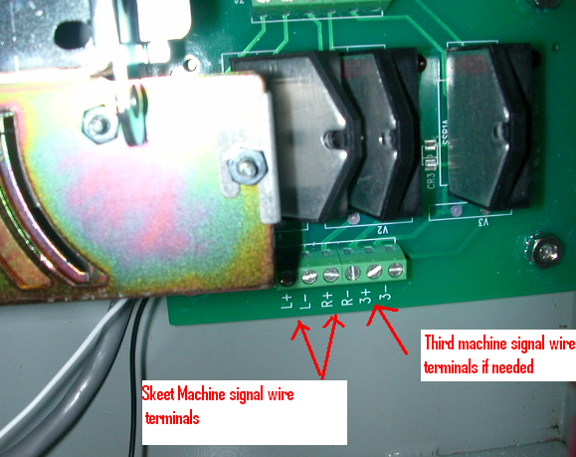
FIG A “shows AC relay board”
Wiring your skeet machines to your relay board which is located on the back of the of the coin box.
All traps have a release cord. This cord has two wires (a common wire and a positive wire, known as the signal wire), when these two wires make contact the machine releases the target. Incidentally, these wires are typically hooked up to the center post terminal where you plug in your pull cord.

Connect skeet machines;
High house
Connect the high house POSITIVE wire to “L+” terminal
Connect the high house COMMON wire to “L-” terminal
Low house
Connect the low house POSITIVE wire to “R+” terminal
Connect the low house COMMON wire to “R-” terminal
Connect ATA trap machines;
Connect the ATA trap POSITIVE wire to “3+” terminal
Connect the ATA trap COMMON wire to “3-” terminal

NOTE!!!!! POLARITY IS IMPORTANT. If you reverse polarity strange things happen! So hook up the positive wire to the positive terminal and the common to the Negative terminal…….

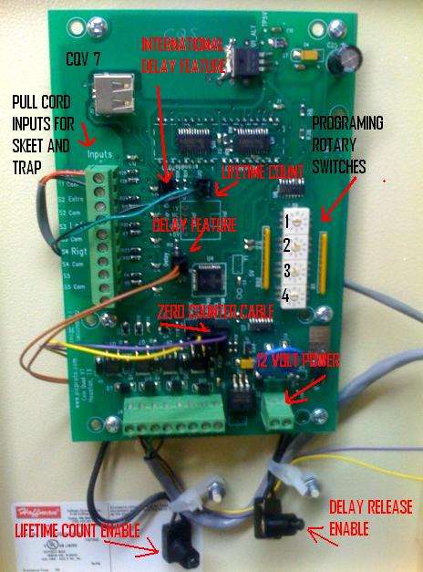
FIG 1
Skeet Installation, pull cord wiring;
Connect your pull cord signal wires to the pull cord terminals as shown on the figure above (top left side). Connect your (pull cord) high house single wire to the terminal marked “LEFT”. Now connect your (pull cord) low house single wire to the terminal marked “Rigt” and finally connect your common wire from your pull cord to the terminal marked “Com” on the terminal that is in-between “Left” and “Rigt” terminals.
ATA Trap Installation, pull cord wiring;
Connect your pull cord signal wires to the pull cord terminals as shown on the figure above (top left side). Your trap pull cord wire will have two wires. One will be the signal wire (connect this wire to the terminal marked “extra”) and the other will be the common wire which connects to the terminal right below it which reads “Com”.
POWER for coin box;
Your coin box operates on 12 volt power. You must provide a 12 volt power source to it. We recommend that
you purchase a 12 volt converter at Radio Shack and use this as a power source. Fig 1 shows (bottom right) the
terminals were you connect 12 volt wires to.

Voice release hook up instructions:

Your voice release system will have a relay box in the trap house. It currently has a two wire cord that connects to the release wires on the trap. Disconnect these two wires. The two wires that come from the trap machine connect as follows on the relay board (fig A);

Connect the ATA trap POSITIVE wire to “3+” terminal
Connect the ATA trap COMMON wire to “3-” terminal

The two wires that come from the voice release relay box connect to the mother board (Fig. 1) as follow;

Connect your voice release wires to the pull cord terminals as shown on the figure 1 (top left side). Your voice release pull cord wire will have two wires. One will be the signal wire [pos] (connect this wire to the terminal marked “S2 Extra”) and the other will be the common wire which connects to the terminal right below it which reads “S2 Com”.

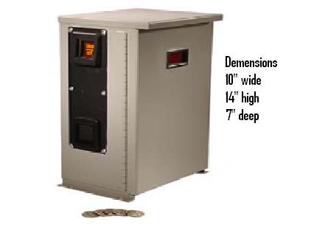

Connect your Skeet, Trap, or Sporting Machines to a coin box.
1. Eight relay capacity (One box can operate up to eight traps)
2. Set the token value 1-99 Targets per
token.
3. The first token can be set for a
different value than the following tokens.
4. The system can be bypassed for tournaments and used as a counter.
5. Available in 12 volt or 110 AC release systems.
6. Is voice release compatible
7. Economically Efficient
-Revenue will increase 20%-40%
-Up to 15% of tokens will never get used due to people losing or misplacing them.
-Total Inventory Control
8. Coin Specifications
-5 different coin sizes
-Coins have laser marked initials so we can control migration and for internal control.
-Coin receivers can be changed
-Coins are only $.39 each
Please note: When ordering we must know if the release on the traps are AC or DC so that we may build the relays to be compatible with coin boxes.
BEOMAT and Superstar - 110AC release
Western and Pat Trap - AC
Mattarelli - DC
Laport - AC or DC

Prices …Trap only $700
Skeet Only $725
Skeet and trap overlay $750
5 stand ( 8 machines) $1250

